Clifford’s Tower: An open brief for development
My Future York, Phil Bixby and Helen Graham
1st November 2018

Introduction and context
This document draws on two strands of work. Firstly the first phase of My Castle Gateway community engagement which led to the development and adoption by the council of masterplan proposals which fundamentally change the setting of Clifford’s Tower. The process itself also has significance in that it has brought about partnership working between the various major stakeholders in the area.
Secondly, on 23rd October a walk and discussion was held with a group of local people who had been involved in the Not in the Motte campaign against the proposed Clifford’s Tower visitors centre. A number of those present had been heavily involved in opposition to the now cancelled proposals, and it was seen as an essential first step to understand the views on the significance of the site which had driven this opposition to its change.
The discussions started with asking the group why they had originally got involved in the campaign in order to inform an understanding of the significance of Clifford’s Tower. We then moved to reflect on how Clifford’s Tower sits in the wider Castle Gateway area with a particular focus on what histories and stories can be told in the area and how this might intersect with the uses and development of the new public space in the Castle car park.
The physical and moving around it:-
The motte
As the name of the campaign suggests, there were strong feelings that the motte as it stands is of enormous significance. Responses pointed firmly towards the aesthetics, symmetry and appearance of the motte as being the key issues. While there was recognition that the motte had not always looked like this, it has done since 1935, is the view depicted by LS Lowry and, as one person put it, ‘it was a moment of civic pride when the motte was restored to its original profile’.
Many participants had only very rarely been up into Clifford’s Tower and those that had found it a ‘bit underwhelming’. For this group the outside of Clifford’s Tower was much more important, as indicated by the emphasis on the visual appearance of the motte.
The motte in context
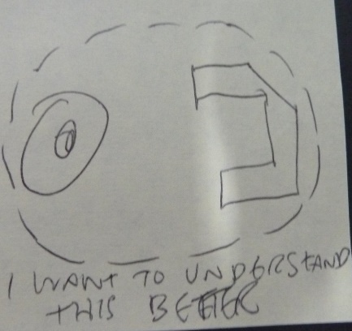
Yet it was a short leap from this commitment to the aesthetics of the motte to a widely held wish that the motte be understood within its wider context and as part of York Castle. In this wider context, the importance of the confluence of two rivers in this story, the visual link to the remaining bailey wall and the ongoing histories of authority and justice were all noted. The scale of the overall castle was discussed and the fact that Clifford’s Tower wasn’t “a very small castle” but was part of a rather large one, now largely invisible and there was a wish for this to be made clear.
Need for a visitor centre? / A joint ticket?
Another reason for objection to the visitor centre was whether it was needed and certainly whether it was needed in the originally proposed location. Many saw opportunity in a visitor centre that did more of this contextual work and sits within the wider Castle Gateway area. There was strong support for some kind of joint ticket that might enable people to visit both Clifford’s Tower and York Castle Museum – and possibly other sites in the area (Fairfax House; Army Museum). There was also discussion about how modern technology could make this easier – that there were now more sophisticated solutions than paper tickets and literal paywalls.
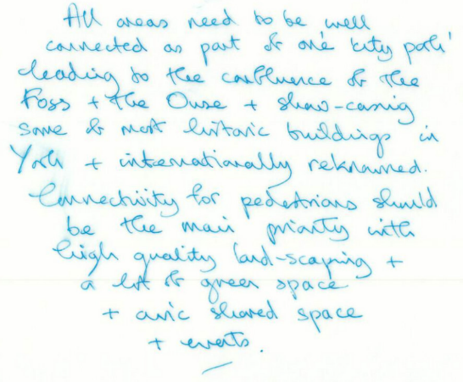
Wayfinding and access
There was discussion (as there had been in earlier workshops looking at movement and meaning) around the issue of arrival and welcome. Visitors arrive from various directions – how do they know when they have “arrived” and how do we convey that message? Was a visitor centre something which could do this?
There was a clear feeling of needing a strong pedestrian link from Castlegate and that the issue of wayfinding started, when coming in that direction, on leaving Coney Street (via what is currently a poor and hazardous junction). It was also recognised that access into Clifford’s Tower inevitably needs to be part of the brief from an English Heritage perspective.
Stories and how/where they are told:-
Stories that need to be told in the Castle area
An interpretive theme that crisscrossed the 1000 years of power, authority and justice was identified. Particular moments mentioned included 1190 massacre of York’s Jewish community, Edward I on his way to Bannockburn, the civil war, Georgian promenade and prison and court buildings – though this list is not exhaustive (see YMT Movement and Meaning report). The area was described as unique in having so many layers of history and presenting challenges of how to tell them in a coherent way.
Stories that can be particularly told from inside or the top of Clifford’s Tower
While there were a number of stories that people felt could be told from the Castle Gateway area generally there were some that had particular potential to be explore from inside or from the top of Clifford’s Tower. For example, the visual link to the rivers and the shape of the landscape beyond and its role in the specific location of the settlement, the visual link to Baille Hill and the shape of the Castle. Yet an emphasis was placed on needing different perspectives within the site to really understanding the big stories, taking us back again to the related issues of a place of welcome separate from Clifford’s Tower and the value of joint tickets in encouraging broad exploration and experience.
How to tell the stories
There was some discussion about whether or how to combine people telling stories as guides, as re-enactments and other forms of live interpretation and technology. There were some principles that emerged and could be explored further: that any interpretation should be well-researched and that it should not be too Disney (though what Disney did well, it was acknowledged, was know their audiences!). There was also a concern that a broader range of stories should be told – that there should be space for personal histories and for valuing individual experience of the place – a mention in discussion about “the true history” brought a sharp response from many that this was a plural, not singular, thing.
Engaging local people: Costs but not only that
There was an acknowledgment that the Castle Gateway area generally – as was borne out in the first phase of My Castle Gateway – would need to think about how to engage and attract local people. The issue of costs – and living in York ‘being an expensive business’ – was raised. However the broader issue of the place being about “more than heritage” was raised – what can the area offer to people who aren’t immediately interested in heritage, or who have been here many times and visited everything? How can heritage be part of helping to create a great place?
The new public space: directions for further conversations
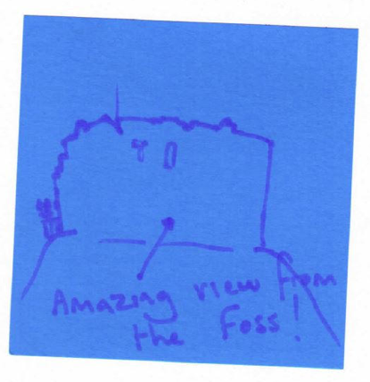
By the end of the session we moved to consider these questions in the context of the new public space. A key principle – already accepted in the Castle Gateway Masterplan – was to get rid of the cars with the sense that people will simply come once that barrier to movement and spending time here was removed. It was noted that the Rose Theatre had created a new view back towards Clifford’s Tower and that there was real scope for the area to be used at night, as it had been for the Illuminations, which was remembered fondly. There was also feeling that quiet and reflective public spaces were important as well as large open spaces that could be used for events.
Next steps
This workshop and the recent York Castle Museum: Movement and Meaning workshops will inform the development of the next phase of My Castle Gateway public engagement.
A central theme which emerged from the workshop was the interaction of people – both visitors and residents – with the buildings and landscape. Understanding this better involves deepening the process of briefing to better understand what can happen where, but also engaging people in making change together by exploring how events and activities can build connections between people and places. There are huge opportunities here – from exploring the interplay of paid and free activities, to simply seeing how new routes through Castle Gateway can unlock meaning, and how this can be exploited. Clifford’s Tower and its setting are key elements in this, and English Heritage should be an active partner in this creative process.
York is fortunate in having a pool of residents who are informed and engaged, and they have already contributed hugely to the My Castle Gateway masterplan. Some of the richest discussion has come from bringing together different interests, and both this workshop and the recent York Castle Museum: Movement and Meaning workshops show the creative possibilities of constantly connecting these conversations.
The establishment of the partnership between council, YMT and English Heritage is hugely helpful in developing this holistic conversation, both in allowing coordinated understanding and development of collaborative ways of working, and also in establishing the possibility of outcomes which bridge ownership and logistics, and provide an environment and interpretation which is driven by the stories of this extraordinary part of the city.

